Candidate Name: | Noela Ephraim Ndunguru | 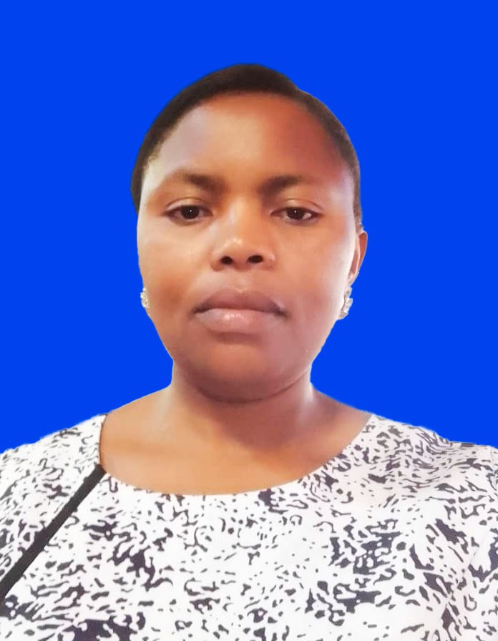
Registration Number: | 2019-07-09128
Institution: | University of Dar es Salaam - School of Education

Qualifications Attained:
Ms. Noela Ephraim Ndunguru is a PhD candidate (by Thesis) in the Department of Educational Psychology and Curriculum Studies, School of Education, at the University of Dar es Salaam. In 2008, She completed her Bachelor of Education in Educational Psychology. In 2009 She started her Master of Arts in Applied Social Psychology in which was completed in 2011, from the University of Dar es Salaam. Currently, Ms. Noela is an Assistant Lecturer at the Department of Educational Psychology and Curriculum Studies, School of Education at the University of Dar es Salaam. She teaches various courses, including Introduction to Educational Psychology, Theoretical and Practical Perspectives to Counselling, Counselling and Special Needs Education, Psychology of Exceptionalities and Inclusive Education. As a researcher, her interest relies on special needs education, parental engagement in children with special needs, supportive facilities and infrastructure as well as resources for children with special needs.

Title of Thesis: | Experiences of Parents and Teachers in Providing Support to Children with Autism in Tanzania’s Primary Schools
Date of Viva Voce: | 24th April, 2024
Venue: | Board Room-SoED
Time: | 10: 00a.m
Supervisors: | Dr. Sarah Kisanga & Joyce Mkongo

Abstract:
This qualitative study explored the experiences of parents and teachers in supporting children with autism in Tanzania’s primary schools. Specifically, the study explored the parents’ and teachers’ conceptualisation of autism; determined the challenges parents and teachers encounter in supporting children with autism; and establish the coping strategies parents and teachers employ in managing challenges to supporting children with autism. Using an interpretative phenomenological design, the study was conducted on two special education units to generate the required information. Through criterion purposive sampling, the study drew 27 participants comprising 20 parents and seven teachers of children with autism. Then using semi-structured interviews and focus group discussions, the study collected qualitative data, which was then subjected to thematic analysis. The study found that the conceptualisation on autism from participants covered neurological disorder, abnormality in development and Gods’ wishes. In addition, parents and teachers experienced challenges such as unfavourable treatment from community members, limited skills to manage behaviours of children with autism, caring burden, and inadequate professionals for children with autism. Furthermore, the study found that both parents and teachers searched for new knowledge on autism to have a firm grasp of the condition, created community awareness and sought support in actuating problem-focused coping strategies. Meanwhile, the parents and teachers employed acceptance and involvement in religious activities as emotional-focused coping strategies. Based on these findings, the study underscores a need for effective mechanism to raise community awareness on autism and ensure accessibility and affordability of human and material resources needed to support children with autism. Moreover, there is a need for ongoing training for parents and teachers of children with autism to equip them with updated knowledge and requisite skills to support children with autism in realising their full potential.

Panel Members
No | Name | Designation | Rank |  | Unit
1. | Prof. Abel Ishumi | Chairperson | Professor Emeritus | SoED-EFMLL
2. | Dr. Cyprian Maro | Representing External Examiner | S/Lecturer | SoED-PESS
3. | Dr. Suitbert Lyakurwa | Internal Examiner | Lecturer | SoED-EPCS
4. | Dr. Sarah Kisanga | Candidate’s Supervisor | S/Lecturer | SoED-EPCS
5. | Dr. Albert Tarmo | Head of the relevant department (or his/her appointee) | S/Lecturer | SoED-EPCS
6. | Dr. Fortunatha Matiba | Co-opted Member (appointed by College/School/Institute | S/Lecturer | SoED-EFMLL
7. | Dr. Benadetha Rushahu | Co-opted Member (appointed by College/School/Institute | Lecturer | SoED-EPCS
8. | Dr. Gissa Andrew | Appointee of the Principal for PhD only) | Lecturer | DUCE-EPCS

